SUNDAY 10th SEPTEMBER
Shipmates attended two events even though they coincided with the Biennial Parade in London.
The first was held at St Osmund’s Church Osmington and was attended by members of Portland, Dorchester and Weymouth Branches. This was to re-dedicate a WW1 Memorial Parchment, which had been discovered in the church tower. The parchment is unusual as it lists not only those who lost their lives but everyone from Osmington who served in The Great War.

The names listed are from Naval and Army units 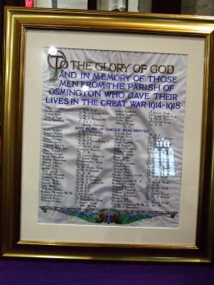
For those who served in the Royal Navy their names are
followed by the name of the ship on which they served.

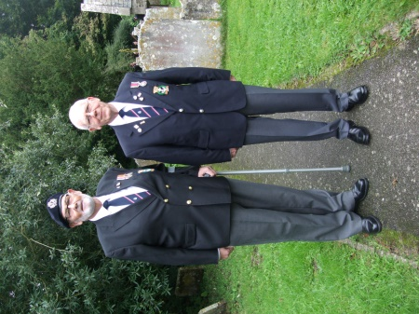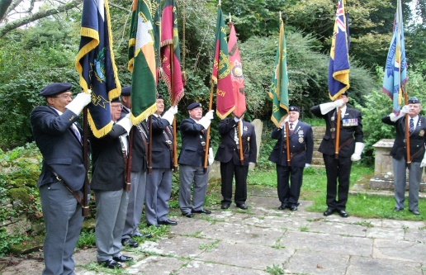

The second service attended by Portland Branch members. took place at St Andrew’s Church, Portland. This was to commemorate the 140th Anniversary of the loss of life following a collision
between the “AVALANCHE” bound for New Zealand and the “FORREST” bound for Canada off Portland Bill.
So shocked were people in New Zealand that they launched an appeal for a Memorial to be erected on Portland. This raised £1000 and it was decided to use the money to build a church.

A representative of the New Zealand High Commissioner also attended the service.

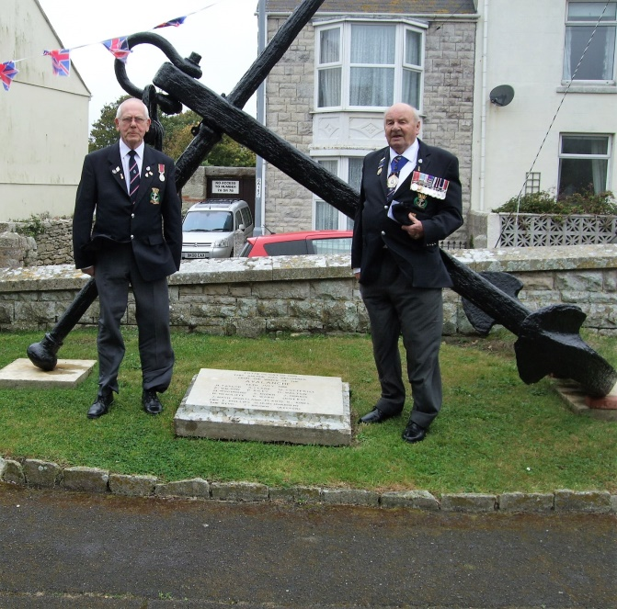

During the service one of the candles which had also been salvaged from the wreck of the “AVALANCHE” was lit.

